SEAANZ Research Book Series

A core purpose of SEAANZ since 1987 has been to enhance the linkages between the community of researchers who study small enterprise and the communities who are engaged in education, policy and practice activities associated with such firms.

The ability to disseminate research across all “four pillars” of our SEAANZ community requires that we make use of as many channels of communication as possible.

In addition to our journal Small Enterprise Research, our conferences, website and newsletter, SEAANZ will now publish a series of research books.

From 2014 to 2018, SEAANZ produced a series of books that addressed a key theme around from the annual conference from the prior years. Details of the series and how to access copies are provided below.

2017
Economic Gardening Entrepreneurship, Innovation and Small Business Ecosystems in Regional, Rural and International Development

This will be available as an e-book shortly

2016

SMEs in the Digital Economy: Surviving the Digital Revolution

https://www.amazon.com/SMEs-Digital-Economy-Surviving-Revolution/dp/0734612311
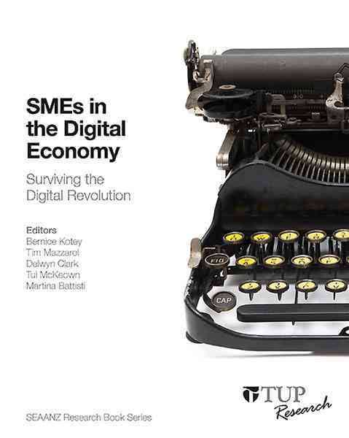
Our small to medium enterprises (SMEs) will face the challenges and opportunities of the global trend towards digital, online and mobile technologies. However, many SMEs are not prepared to engage with these digital technologies, while others seem unwilling to embrace them.
SMEs in the Digital Economy explores the many benefits, but also some of the risks, for SMEs in the digital economy. The overall message is that it is crucial to engage with the digital economy. Ignoring it is not an option. Owner-managers need to improve their knowledge and acquire the skills to effectively participate in the emerging digital market.
This book contains ten chapters from a range of specialist authors. Each chapter has a unique but important message on the impact of the digital economy on SMEs in Australia and New Zealand, and the various ways in which SMEs are engaging in this economy. It reflects the diversity of issues and complexity of small business as an area for government, industry and academics seeking to shape effective policies to support this important sector.
2015
Rhetoric and Reality: Building Vibrant and Sustainable Entrepreneurial Ecosystems.
https://www.amazon.com/Rhetoric-Reality-Sustainable-Entreprenurial-Ecosystems/dp/0734612575

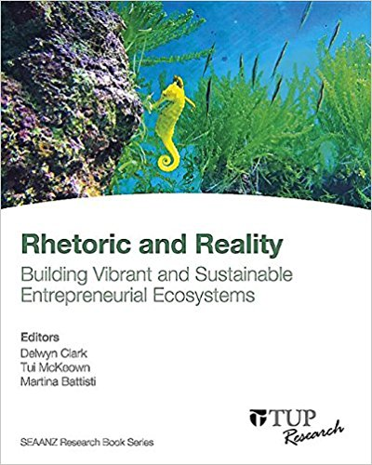
Growing and sustaining entrepreneurial ecosystems will drive the success of future SMEs. Following on from the 2014 G20 Leaders’ Summit and G20 SME Conference held in Australia, SEAANZ has outlined some of the key components of an entrepreneurial ecosystem including government policy, regulation, infrastructure and financing, as well as the importance of the nano-business. It is imperative that SMEs understand the nature of the entrepreneurial ecosystem which has become a key framework for driving economic development, innovation and small enterprise growth.
Rhetoric and Reality: Building Vibrant and Sustainable Entrepreneurial Ecosystems examines areas such as: the law and access to justice for small firms, opportunities for collaboration and support between large and small firms, growing indigenous enterprises, improving the manufacturing sector, collaboration within cooperatives and mutual enterprises, the Lego entrepreneur approach, the impact of intellectual capital, environmental and social sustainability practices, and the role of universities as catalysts within the entrepreneurial ecosystem.
This book contains ten chapters from a range of specialist authors, with particular emphasis on: understanding specific issues for SMEs and/or components of the entrepreneurial ecosystem; reviewing prior research; identifying best practices; and revealing gaps in current policies, practices or research. The book reflects the diversity of issues and the complexity of small business as an area for government, industry and academics seeking to shape effective policies that will support this important sector.
2014
Meeting the globalisation challenge: smart and innovative SMEs in a globally competitive environment
https://www.amazon.com/Meeting-Globalisation-Challenge-Competitive-Environment/dp/0734611927
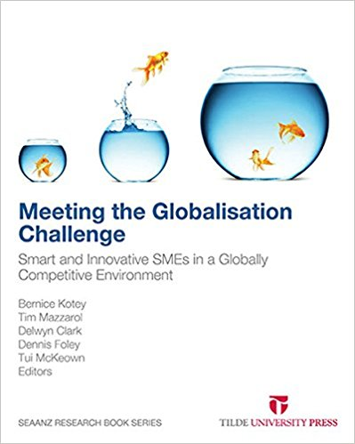
SEAANZ has launched this work in order to provide a more accessible source of information for readers than is possible with traditional academic journals. This book brings together authors who represent a cross-section of the ‘four pillars’ that comprise the SEAANZ community – academic researchers, educators, public policy specialists and practitioners from the small business sector. Many SME owners are doing it tough in an uncertain environment where margins are squeezed and returns reduced. More than ever, Australasian SMEs are facing a unique combination of global, structural and cyclical forces than threaten their ability to take advantage of emerging opportunities. These threats – including rapid technological change, intense global competition, and unfavourable trading conditions – cumulatively create significant environmental uncertainty for SMEs. Meeting the Globalisation Challenge: Smart and Innovative SMEs in a Globally Competitive Environment identifies ways SMEs can tackle these challenges. The book comprises twelve chapters, organised into three parts. Readers are introduced to the sources of innovation in SMEs, proposals to reduce the regulatory burden for the sector, and systems that support innovation in SMEs in times of change. Contents: Chapter 1 – Introduction: Smart and innovative SMEs, Part I: Innovation in SMEs, Chapter 2 – Commercialisation in SMEs: Case studies from Australia, New Zealand and the United States, Chapter 3 – The independent professional: An untapped source of innovation, Chapter 4 – A structured approach to innovation: ‘Opportunity capture’ and ‘systematic thinking’, Chapter 5 – Management practices in medium-sized enterprises: Insights from benchmarking Australian manufacturing firms, Part II: Regulation, ‘Red Tape’ and the Need for Better Communication, Chapter 6 – Regulator engagement with small business, Chapter 7 – Is anybody listening?: Improving government information and communication to small business, Chapter 8 – SME research and policy challenges: How to classify SME research and connect SME researchers and policy makers, Part III: Supporting SMEs in Times of Change, Chapter 9 – Small businesses so poorly managed in the digital age: Is there a solution?, Chapter 10 – Wealth and small business ownership in Australian households: What rewards for business proprietors?, Chapter 11 – Exit planning in small Australian firms, Chapter 12 – Current issues in Aboriginal SMEs

